Software Design Document

Accident Analysis Software

Nicolas Donaldson – S5256284

Juniper Lethbridge – S2884940

Table of Contents

1.0 System Vision 3

1.1 Problem Background 3

1.2 System Overview 3

1.3 Potential Benefits 3

2.0 Requirements 4

2.1 User Requirements 4

2.2 Software Requirements 4

2.3 Use Cases 4

3.0 System Components and Software Design 5

3.1 System Components 5

3.2 Software Design 5

4.0 User Interface Design 6

# System Vision

## Problem Background

A dataset containing data on Victoria State Accidents presents opportunities to discover underlying causes and other statistics surrounding road accidents that occur in Victoria. Software is required to perform an analysis on the data and present the data to the user in a way that is accurate, interpretable, and relevant. An increase in data has required the Department of Transport for Victoria to seek software that can draw conclusions and present findings, so that the Department of Transport may overcome the challenges associated with data analysis and human error. As data becomes too large, it becomes impossible to analyse the data without errors, misunderstandings, and large amounts of human resources. This is the problem the software intends to solve.

## System Overview

The system intends to provide a user-friendly interface that correctly and promptly returns search queries. The system will include functions that:

* For a user-selected period, displays the information of all accidents that happened in the period.
* For a user-selected period, produces a chart to show the number of accidents in each hour of the day (on average).
* For a user-selected period, retrieves all accidents caused by an accident type that contains a keyword (user entered), e.g., collision, pedestrian.
* Allows the user to analyse the impact of alcohol in accidents – ie: trends over time, accident types involving alcohol, etc.
* One other ‘insight’ or analysis tool

## Potential Benefits

Implementing software in the context of data analysis, alleviates the pressure on humans to avoid producing errors in the analysis. Without software, the Department of Transport may spend countless human and financial resources on producing results that software can produce within seconds. By streamlining long tasks into functions that can be performed by software, the Department of Transport can benefit with increased employee productivity and streamlined processes. Software can discover patterns and statistics that are otherwise impossible for humans to observe from a dataset. With this knowledge, the Department of Transport can benefit greatly with the software’s ability to guide the data analyst to solutions not recognised from just the human’s perspective on the data.

# Requirements

## User Requirements

As the client is the Department of Transport for Victoria, it is expected that it is employees of the Department that are the end users of the program. The end user must first begin with inserting the dataset. Once entered, the user may toggle between variations of the user interface. It is only required that the user enters certain parameters surrounding the nature of the user’s query. Once decided, and entered, the results of the user’s query shall be viewable via the output.

In a sequential list of needs, the above would be translated to:

1. Open program
2. Insert Dataset (if first time using application)
3. Insert Query Parameters
4. View Results

Each function will be available from the main view tree in the user interface, with the required function being run dependant on the user input. A field will be available for users to input keywords, which will limit the data output to accident data only containing those keywords.

Options to limit the timeframe will be displayed, if a user decides to use this function the output will be limited to data from within this function. If no time is specified, then all relevant data from the dataset will be displayed.

All data queries will be returned in table format.

Once the data has been displayed, a button to display a chart for the average number of accidents in each hour of the user specified period will appear above the returned data. If this button is pressed a chart will be generated and will be displayed above the tabulated data.

There will also be a radio button which will allow the user to specify that they wish to analyse alcohol related incidents. If this button is checked, a chart will be displayed showing both alcohol and non-alcohol related incidents over the user-specified period, as well as the tabulated data from both alcohol and non-alcohol related incidents in different tables.

**Function 5 is still up in the air – to discuss @ next meeting.**

In addition to this, the end user should be aware that their query is being processed. To provide this context a loading prompt should be displayed to make the end user aware that their query has been accepted and should be displayed soon.

In this section you detail how a user is supposed to interact with or use your program. What do they ***need*** to be able to do? This should all be from the end users perspective. Can be a combination of narrative text and listing of needs.

**Assignment note: You have not been given a client/user, so you can make one up. Who do you think would be using your software?**

## Software Requirements

1. The program shall have a GUI implementation
   1. The program shall allow for user input through GUI
   2. The program shall accept .csv dataset files from user input *and convert to JSON*
   3. The program will limit returned data by user inputted keyword.
   4. The program will limit returned data by time range
   5. The program shall graphically display data through charts & tables
   6. The program shall output a brief summary of results
2. The program shall have maths & statistical modules
3. The program shall have a datetime module.
4. The program shall have a GIS module?

In this section you detail what the requirements for the software are. What functionality will it provide? This is usually a formal listing, with requirements often using the word ‘Shall’. IE:

R1.1 The program shall accept multiple file names as arguments from the command line.

R1.2 Each file name can be a simple file name or include the full path of the file with one or more levels.

etc …

Can be primarily functional requirements, though you may include other types if you think of them.

## Use Cases & Use Case Diagrams

In this section you provide some use cases showing how people may use your software.

|  |  |
| --- | --- |
| Use Case | Import dataset |
| Primary Actor | Client |
| Secondary Actor | System |
| Description | User selects dataset to import into the program and analyse. |
| Flow of events | User imports a .csv document which the system then validates to ensure required fields are present. |
| Trigger | The client requires to analyse accident data within Victoria. |
| Pre-condition | The client chooses a dataset to import into the system to analyse. |
| Post-Condition | The imported dataset is within the analysis system. |
| Success Scenario | User successfully imports dataset into the system. |
| Abort Scenario | User does not import a dataset into the system. |
| Extension Points | Once the dataset has been validated the file is converted into a JSON format. |

|  |  |
| --- | --- |
| Use Case | Convert to JSON file |
| Primary Actor | System |
| Secondary Actor | Nil |
| Description | The user selected dataset is converted from .csv format into a .JSON format |
| Flow of events | The validated .csv file is converted into a JSON format |
| Trigger | The client requires to analyse accident data within Victoria. |
| Pre-condition | The user imported csv file is successfully validated. |
| Post-Condition | The csv file is converted into a JSON file format. |
| Success Scenario | The file format is successfully converted from a csv format to a JSON format |
| Abort Scenario | The csv file fails to convert. |

|  |  |
| --- | --- |
| Use Case | Search Dataset |
| Primary Actor | Client |
| Secondary Actor | System |
| Description | User selects parameters to refine displayed data |
| Flow of events | User inputs and defines parameters to display a range of data. The data is then displayed |
| Trigger | The user defines search parameters |
| Pre-condition | The user defines search parameters |
| Post-Condition | Nil |
| Success Scenario | Records within user defined parameters are displayed |
| Abort Scenario | No records found with user defined parameters |
| Extension Points | Once data has been displayed, user has an option to generate a chart or to overlay accident data onto a map to visually represent the data. |

|  |  |
| --- | --- |
| Use Case | Generate Chart |
| Primary Actor | Client |
| Secondary Actor | System |
| Description | A graphical representation of previously displayed data is generated and displayed. |
| Flow of events | Previously displayed data is read by the system and a graph is displayed. |
| Trigger | The user |
| Pre-condition | Records within a set of user defined parameters are displayed |
| Post-Condition | Nil |
| Success Scenario | A graphical representation of records within user defined parameters is displayed |
| Abort Scenario | No records found with user defined parameters |

|  |  |
| --- | --- |
| Use Case | Generate Map Chart |
| Primary Actor | Client |
| Secondary Actor | System |
| Description | Accident data is overlayed onto a map |
| Flow of events | Previously displayed data is read by the system and datapoints are overlayed onto a map to visually represent the data. |
| Trigger | The user |
| Pre-condition | Records within a set of user defined parameters are displayed |
| Post-Condition | Nil |
| Success Scenario | An overlay of records within user defined parameters is displayed on a map of the relevant area. |
| Abort Scenario | No records found with user defined parameters |

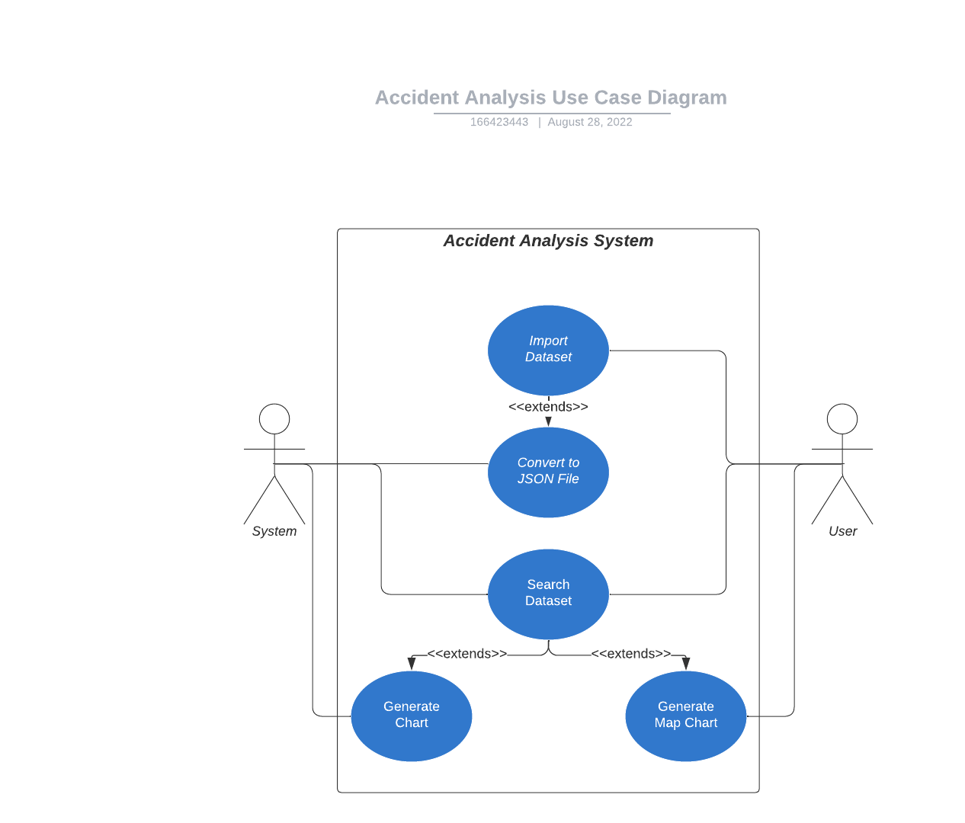

Figure : Accident Analysis Use Case Diagram

# Software Design and System Components

## Software Design

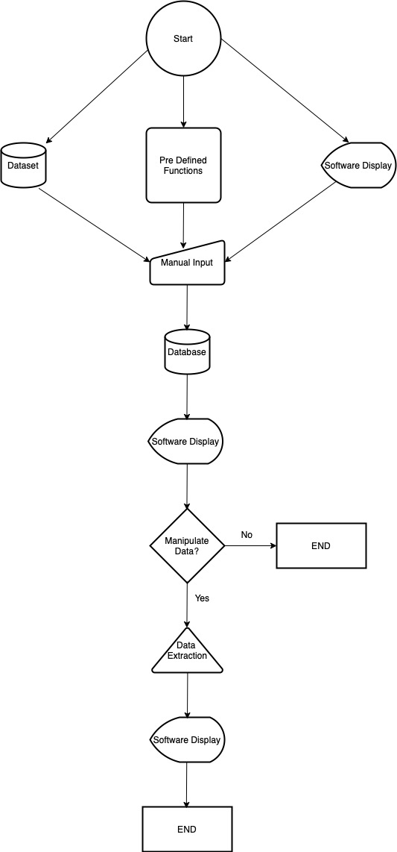

## System Components

### Functions

Preliminary list of all functions in the software. For each function in the list the following information is provided:

* a brief description of what it does (1 or 2 sentences);
* a list of the input parameters, and their data types, and what they are used for;
* a list of any side effects caused by the function (ie change global or member variables, changes data passed by reference from calling function etc)
* a description of the function’s return value

**Function 1:**

**Description**: For a user-selected period, display the information of all accidents that happened in the period.

**Input Parameters**: (Time1, Date1, Time2, Date2)

**Data Types**: (datetime (from datetime module)

**Side Effects**: NIL (pending)

**Return Value**: ALL results between Time1, Date1 AND Time2, Date2

**Function 2:**

**Description**: For a user-selected period, produce a chart to show the number of accidents in each hour of the day (on average). This function extends upon function 1.

**Input Parameters:** (Time1, Date1, Time2, Date2, show chart True/False [button])

**Data Types**: (datetime (from datetime module)

**Side Effects**: NIL (pending)

**Return Value**: IF TRUE: Return Chart between Time1, Date1 AND Time2, Date2 ELSE return information between Time1, Date1 AND Time2, Date2

**Function 3:**

**Description**: For a user-selected period, retrieve all accidents caused by an accident type that contains a keyword (user entered), e.g., collision, pedestrian. This function extends upon Function 1.

**Input Parameters:** (Time1, Date1, Time2, Date2, keyword[string])

**Data Types**: (datetime, string)

**Side Effects**: NIL (pending)

**Return Value**: ALL results between Time1, Date1 AND Time2, Date2 WHERE accident type = keyword

**Function 4:**

**Description**: Allow the user to analyse the impact of alcohol in accidents – ie: trends over time, accident types involving alcohol, etc.

**Input Parameters:** (Time1, Date1, Time2, Date2, keyword[string], predefined filter settings)

**Data Types**: (datetime, string)

**Side Effects**: NIL (pending)

**Return Value**: Graph of ALL results between Time1, Date1 AND Time2, Date2 WHERE accident type = keyword. Up to two sets of results (non-alcohol, alcohol) for user to compare.

**Function 5:**

**Description**: Visualisation tool using Google Maps overlay for user to understand accident data relating to geographical location information.

**Input Parameters:** (Time1, Date1, Time2, Date2, pulldown menu of accident type, alcohol related (true/false))

**Data Types**: datetime, boolean, string

**Side Effects**: NIL (pending)

**Return Value**: geolocation latitude, longitude, maps overlay?, accident details when clicked, google streetview of location (bonus function would be nice =3)

### Data Structures / Data Sources

|  |  |  |
| --- | --- | --- |
| Data | Structure | Description |
| CSV dataset file | CSV Table | This file contains accident data from Department of Transport and saved as CSV file. This will be imported to the software. The dataset file should contain columns of ACCIDENT_NO, ACCIDENT_DATE, ACCIDENT_TIME, ACCIDENT_TYPE, DAY_OF_WEEK, SEVERITY, LONGITUDE, LATITUDE, LGA_NAME, REGION_NAME, FATALITY, SERIOUSINJURY, ALCOHOL_RELATED. |
| JSON dataset file | JSON (Tree) | This file will be created when the software imports the CSV dataset file. Analysis in the software will use this data. The members will be dataset, analyse, alcohol, and location. The keys will include ACCIDENT_NO, ACCIDENT_DATE, ACCIDENT_TIME, ACCIDENT_TYPE, DAY_OF_WEEK, SEVERITY, LONGITUDE, LATITUDE, LGA_NAME, REGION_NAME, FATALITY, SERIOUSINJURY, ALCOHOL_RELATED. |
| Menu | Array | This is to determine which content to display and set different type of analysis to perform. The members will be dataset, analyse, alcohol, and location. |
| Analysis type | Array | This is a list to contain types of analysis which includes general, alcohol, and location. This data will be used to determine attributes for search and which type of chart to generate. The members will be general (default), alcohol, and location. |
| Search attribute |  | This is to determine which search criteria will be available for the analysis functions to search the dataset. Available attributes will be different depending on which analysis type is chosen. From data, to data, accident type keyword, accident type list, and output type will be the members for the general analysis function. |
| Accident type | List | This data will be generated from JSON dataset file referencing the values in the ACCIDENT_TYPE field. This list will be used by the search attribute to perfume an analyse search. |
| Output attribute | key-value dictionary | This data to store the preference of which fields (attributes) to show in the output of analyse search in the table view. True/False Boolean values will be stored for each output type. The keys will be same as JSON dataset file. |
| Chart type | Tree | This data contains different types of chart and its preference. Each type will define which field from the search result to use, and how to display for generating a chart graphic image to display in the chart windows. |
| Search result records | JSON (Tree) | This data will be generated by the search dataset function and stores result records. |
| Summary values | key-value dictionary | This data contains total values of records, fatality, and injury which are generated by the search dataset function. This will be used to display search result summary. |

List of all data structures in the software (eg linked lists, trees, arrays etc) or eternal data sources. For each data structure in the list the following information is provided:

* Type of structure (tree, list etc),
* Description of where and how it is used
* List of data members, and what each one is for do
* List of functions that use it

### Detailed Design

The following pseudocodes demonstrate how each non-standard function in the software will perform.

#### Import dataset

Input file name and location.  
If the file exists, examine the file format and file content of the CSV dataset file.  
Else error: File does not exist.  
If file format is CSV and column names include the required fields, perform the function: convert to JSON file.  
Else error: File format is not CSV and it does not contain required fields.

#### Convert to JSON file

Import csv and json python packages.  
Set a path and filename of the CSV dataset file.  
Set a path and filename to save a JSON dataset file.  
Read the CSV file with csv package.  
Create a JSON file.  
Save the data to the JSON file.

#### Search dataset

Import json python package.  
Read the JSON dataset file.  
If date range is set in the search attributes, find records within the date range.  
If accident type is set in the search attributes, find records with the accident type.  
If the found records is more than zero, save the records and output values with only output attributes that are defined True.  
Else display a message: No record found.  
Calculate summary values (total records, fatality total, injury total) to display.

#### Generate chart

Import library for chart creation (PyPlot library).  
Check which type of chart (chart type) selected.  
Read the search result records generated from the search dataset function.  
Calculate total value for each attribute.  
Allocate colours for attributes and set labels.  
Generate a bar chart.  
Display the chart with legend.

#### Generate map chart

Import library for chart creation (PyPlot library).  
Read the search result records generated from the search dataset function.  
Allocate colours for attributes and set labels.  
Convert LONGITUDE, LATITUDE values in the records to X, Y values to place in the chart.  
Draw circles with the X, Y values with setting colours depending on the accident type.  
Generate a bar chart with a background Victorian map image.  
Display the chart with legend.

Pseudocode for all non-standard / non-trivial algorithms that operate on data structures

# User Interface Design

This is your initial interface design. Describe the tools you used for this design stage and any key findings that informed your design. This introduction is descriptive and should explain what you have completed for the actual design work you will present in the sub-sections below.

<add some intro>

<write about tools used>

## Structural Design

Structural design refers to the navigational and information structure of your product – the structure that supports the interface layout. How will you structure your product? How will you group your information? How will you navigate through your product? Why? This can take the form of a diagram showing structure and hierarchy, supported by a discussion and justification of your choices. Why have you made these design choices? Describe and outline the structure of your interface and of your information.

The software consists of three windows including the main window. The structure of the main window is designed to indicate steps that users follow by placing sections from top to bottom. The estate of main window is limited, thus, charts will be displayed in a secondary window to create more display surface area.

### Main window

The main window of the software contains the following sections. In order to provide the best useability, there are grouped by action which are navigate, search, result (view), summary (view), and chart (view).

**Navigation tool bar**

This section is located at the top of the main window and contains buttons to perform the main functionalities. They are Dataset, Analyse, Alcohol, and Geographical.

**Data search box**

This section is located under the navigation tool bar and contains input fields for users to define search criteria such as dates, and accident type along with a search button to initiate data search.

**Data table view**

This section displays output data in a table view. It is located under the data search box and users can see search result.

**Chart selection bar**

This section is located at the bottom of the main window under the data table view. It shows available chart types which users can view by clicking. This section will not be available when there is no available option.

**Summary view**

This is located at the right side next to the data search box to show summary of result from a search. It can include number of record found, total number of target records, and total number of injury/fatality.

### Chart window

A secondary window will open when users select one of options in the chart selection bar. It displays chars with selected conditions. This window is independent from the main window and can be placed anywhere in users’ screen. Users can close this window without affecting the main operation of the software.

### Dataset window

A window that contains the navigation bar same as the main window. A file selection will be placed in the middle of the window. This window will be shown if there is no dataset imported or selected.

## Visual Design

Detail your visual design: Layout, visual elements, icons, graphics, style, colour, fonts general screen designs. This can be sketches, wireframes, mockups etc, supported by a discussion, explanation, and justification of your choices.

### Layout

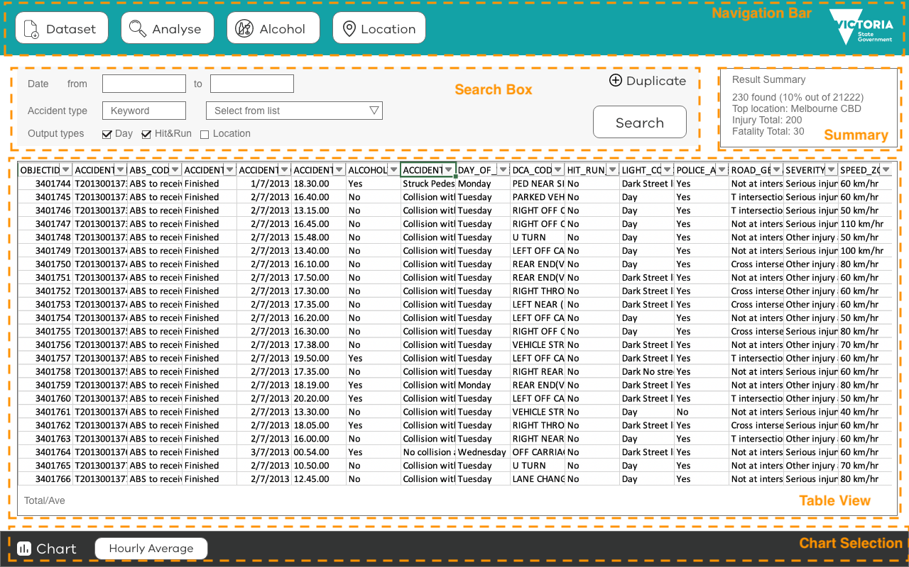

Figure 2 Main Window Layout

### Visual Elements

#### Logo

The client’s logo, Victoria State Government logo, will be placed in the navigation bar sourced from Brand Victoria website (<https://www.vic.gov.au/brand-victoria-using-our-logos>). The colour of the logo will be adjusted to white to have a contrast against the background colour.



Figure 3 Victoria State Government logo

#### Icons and Buttons

|  |  |  |
| --- | --- | --- |
| Graphic | Name | Description |
|  | Dataset Icon | Used in the button for the Dataset menu to indicate importing a file. Open a dialog to select a file to import to use as a dataset. |
|  | Analyse Icon | Used in the button for the Analyse menu to indicate to set search conditions. Displays the standard search box to analyse data. |
|  | Alcohol Icon | Used in the button for the Alcohol menu to indicate the data analysis of alcohol related accidents. Displays the extended search box to analyse alcohol related accidents data. Slashed version is selected to be work environment friendly instead of non-slashed designs. |
|  | Location Icon | Used in the button for the Location menu to indicate the geographical data related analysis using maker which is used in map apps often. Displays the extended search box to analyse accidents data by area or location. |
|  | Chart Icon | Used to supplement the Chart title in the chart selection bar to indicate the section is about charts. |
|  | Search Button | Buttons have round corners to indicate the actions are assigned to them as well as create the soften the impression of the software. |
|  | Navigation menu button | Buttons have round corners and a label with an icon to indicate that they are main menus in the software. They are placed in the navigation bar at the top. The size is bigger than other elements to stand out. |

### Colour

The most key colours for the software are chosen as same as the Department of Transport Victoria website to be cohesive and adhere the client’s corporate ID (see figures below).

|  |  |  |
| --- | --- | --- |
|  | Colour Name (Code) | Description |
|  | Teal (#13a2a6) | The feature colour that is used for the Department of Transport Victoria website. This colour is used for the background of the navigation bar in the software. |
|  | Dark grey (#333434) | The colour is used for the background of the chart selection bar at the bottom of the software. It is the same colour that is used for the client’s website as the footer background colour. It is also used as the text colour of menu buttons and table view body content. |
|  | Grey (#707070) | This colour is used for the secondary text labels such as labels in the search box and the result summary box. Its shade is lighter than the dark grey (#333434) while it holds the decent readability. |
|  | Light grey (#F7F7F7) | This colour is used for the background of the search box to indicate the distinct area and separate from adjacent sections. The shade of this colour is adjusted to keep enough contrast with text elements in the section for maximum readability. |
|  | White (#ffffff) | This colour is used for the background of the majority space in the software to deliver the clean look and feel. It is the same colour which has been used for the background of the client’s website. It is also used for the colour of the buttons in the navigation bar to make a contrast with the navigation bar background colour. |

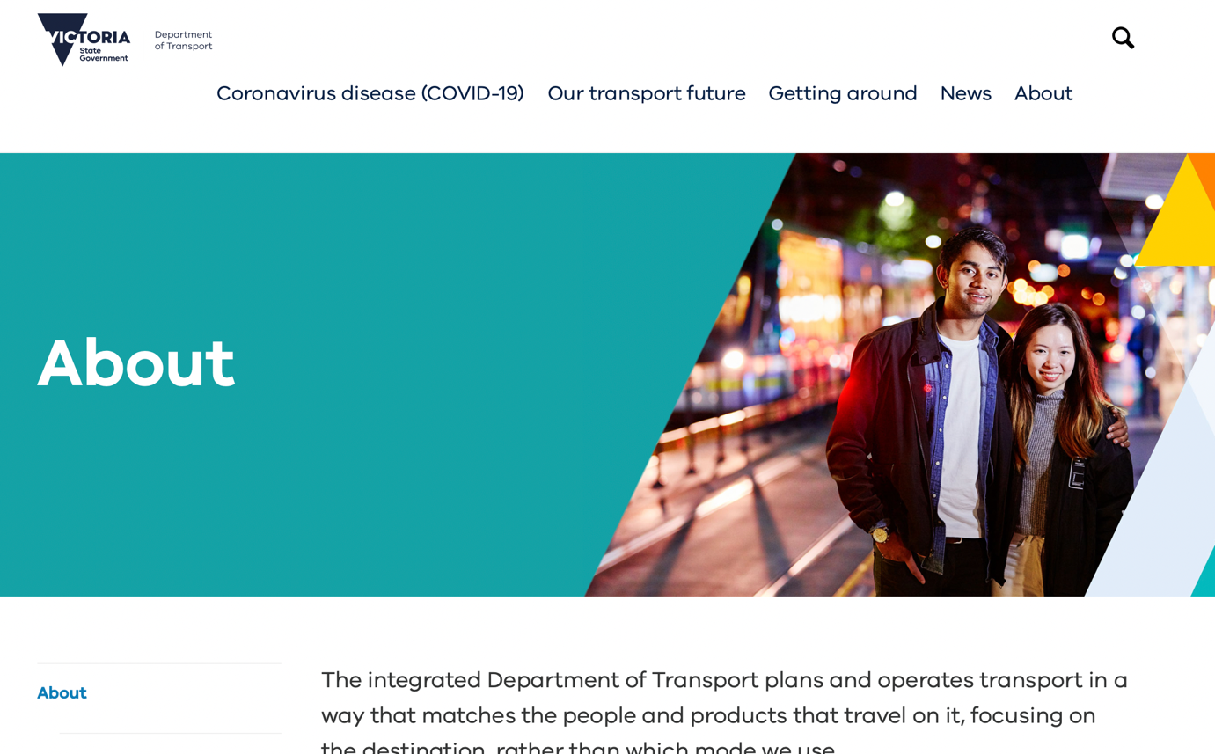

Figure 4 Department of Transport Website



Figure 5 Department of Transport Website Footer

### Font

#### Feature Font

The VIC font will be used for headings and labels of buttons in the software. This is to adhere the design guidelines defined by the client, Victorian Government. The font files are available on vic.gov.au website (<https://www.vic.gov.au/brand-victoria-fonts>) for download to use.

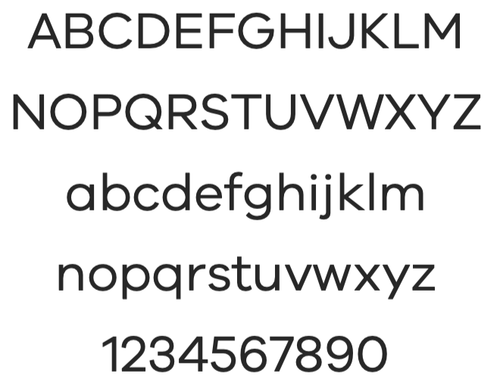

Figure 6 VIC font

#### Body font

Arial font will be used for body text elements as instructed in the font usage guide on the client’s website.

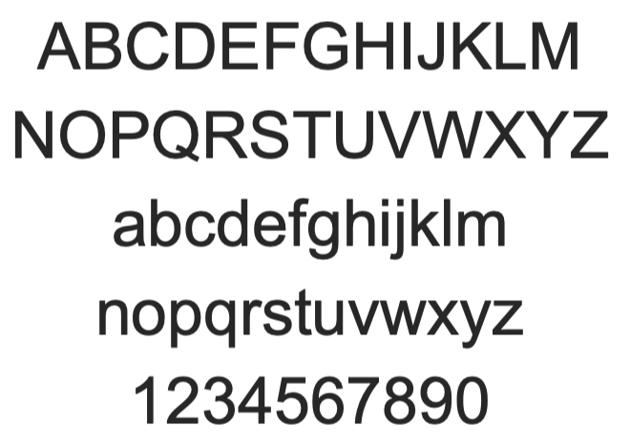

Figure 7 Arial font

### Mock-up Screens

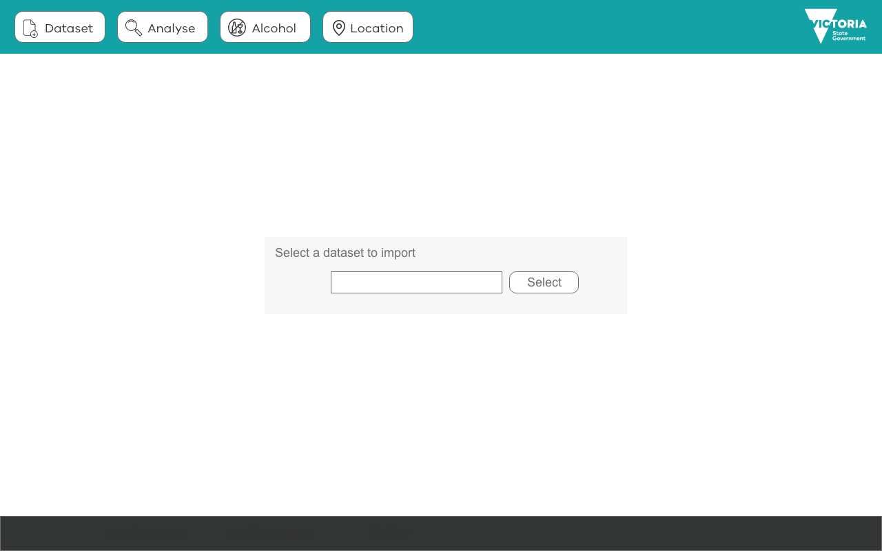

Screen 1 Dataset Selection

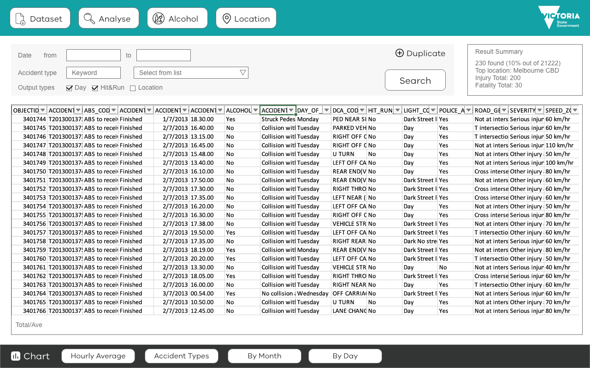

Screen 2 Analyse

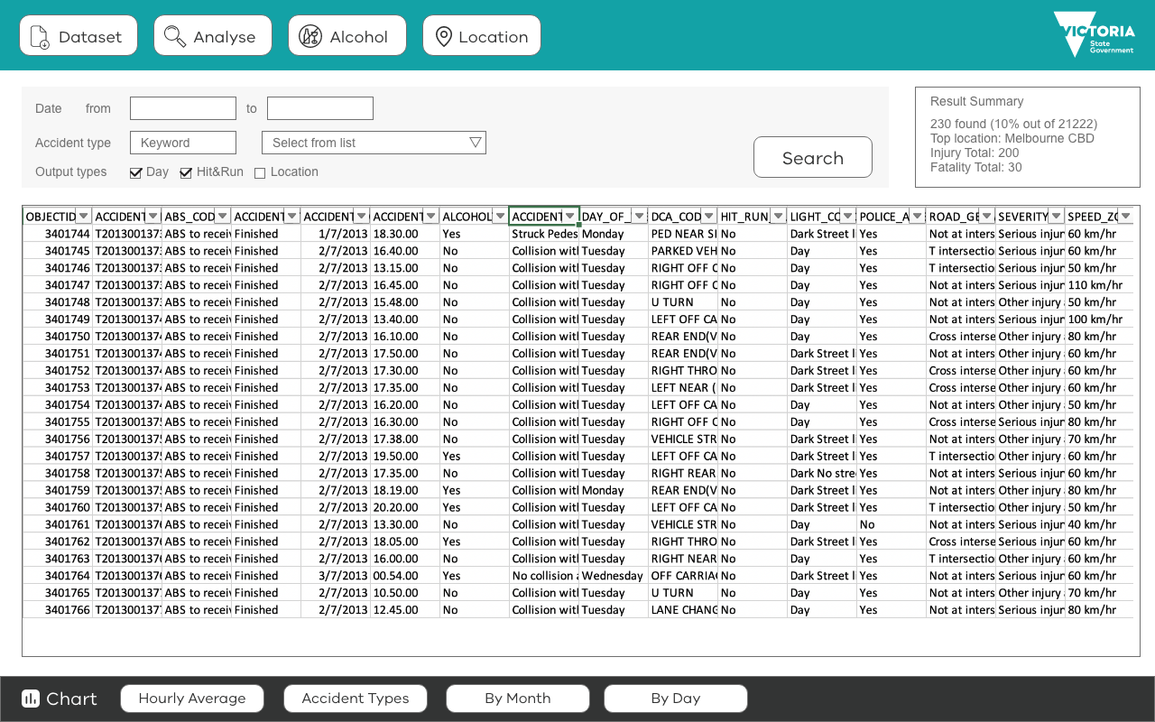

Screen 3 Alcohol Section

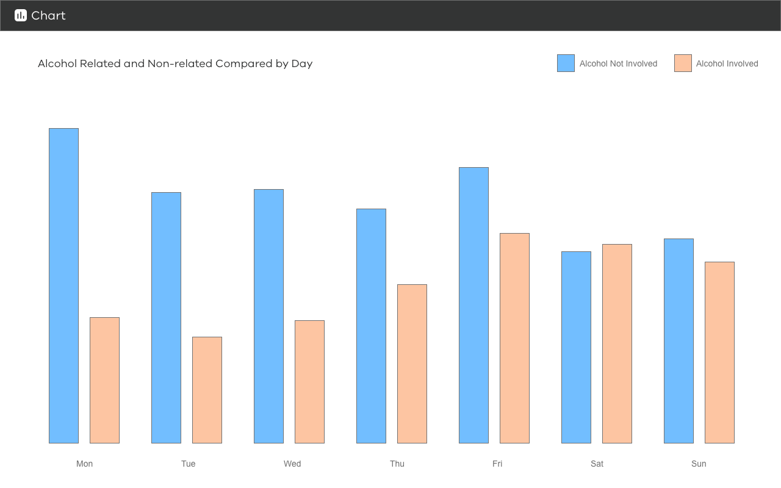

Screen 4 Chart Alcohol Related

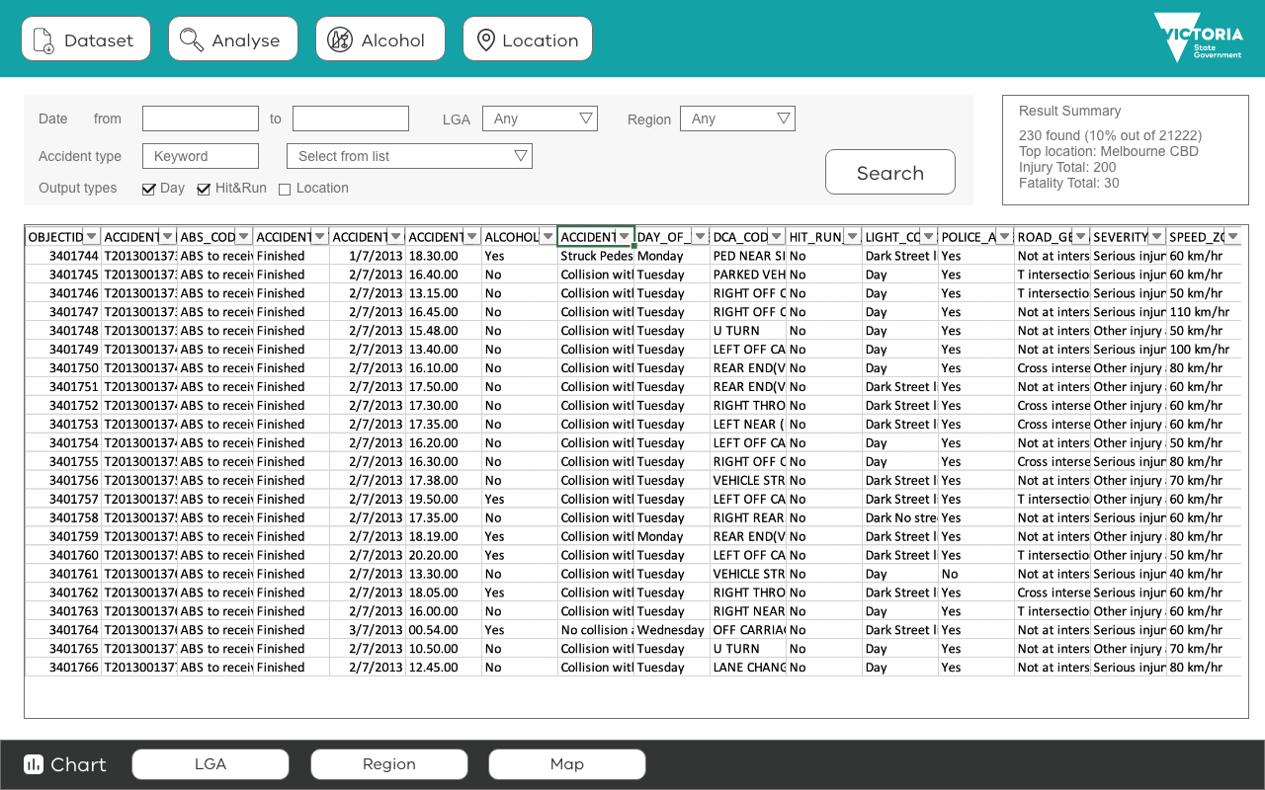

Screen 5 Location

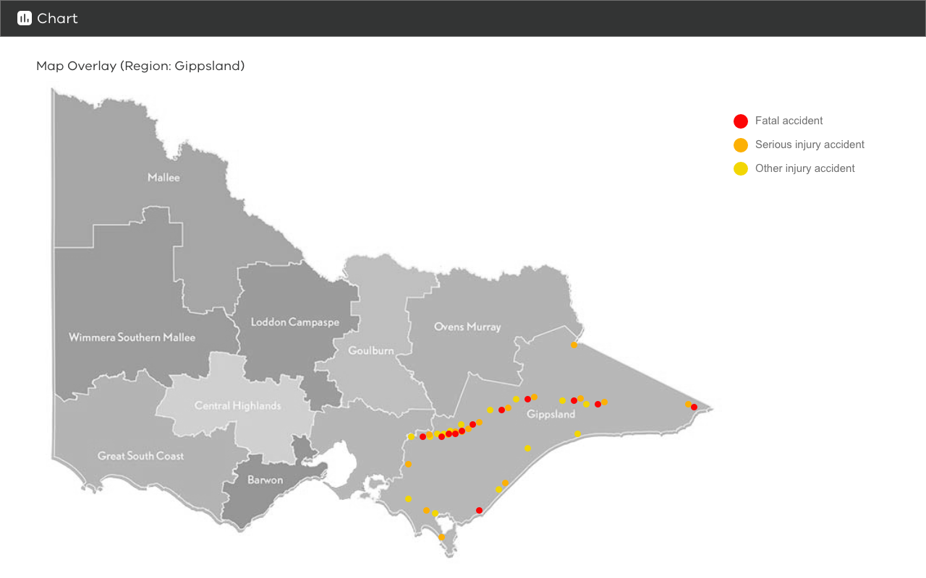

Screen 6 Chart Map